MASTER OF SACRED THEOLOGY
THESIS APPROVAL
The following thesis entitled
[THESIS TITLE: SUBTITLE]
and written by
[Student’s Full Name]
has been Submitted
to the Concordia Theological Seminary Faculty
in Partial Fulfillment of the Requirements
for the Degree of
MASTER OF SACRED THEOLOGY
This Thesis stands Approved on this
______ day of _____________________, 20_____
having been read by the undersigned members
of the Thesis Committee
____________________________________
[Title and Full Name], Advisor
____________________________________
[Title and Full Name], Reader
____________________________________
[Title and Full Name], Reader
____________________________________
[Title and Full Name], STM Director

[THESIS TITLE: SUBTITLE]
by
[Student’s Full Name]
[Degree, School, Location, year]
A THESIS

Submitted to the Faculty of
Concordia Theological Seminary
in partial fulfillment of the requirements
for the degree of
MASTER OF SACRED THEOLOGY

Fort Wayne, Indiana
[Month, year]

ABSTRACT
[Student’s Last Name, First Name, M.I.] “[Thesis Title: Subtitle].” STM thesis, Fort Wayne, Indiana: Concordia Theological Seminary, [20__]. 21 pp. [right click page number and select “Update Field.”]
[Abstract text.]

[Dedication text]

CONTENTS
ILLUSTRATIONS vi
TABLES vii
PREFACE viii
ACKNOWLEDGEMENTS ix
ABBREVIATIONS x
GLOSSARY xi
Chapter
- INTRODUCTION 1
Sample Level One Subheading 1
Sample Level Two Subheading 1
Sample Level Three Subheading 1
- BIBLICAL AND CONFESSIONAL ISSUES 3
- LAW AND GOSPEL 4
- REFORMATION CONTRIBUTION 5
- LITURGY AND CONFESSIONS 6
- CONCLUSIONS AND IMPLICATIONS 7
Appendix
- APPENDIX ONE TITLE 8
- APPENDIX TWO TITLE 9
WORKS CITED 10

ILLUSTRATIONS
Figure 1. The Seasons of the Church Year 3

TABLES
Table 1. Population Trends in NE Brazil 2

PREFACE
[Preface text]

ACKNOWLEDGEMENTS
[Acknowledgements text]

ABBREVIATIONS
[ABBREV Abbreviation text]

GLOSSARY
[Term: Definition of term]

CHAPTER ONE

INTRODUCTION
[This Microsoft Word template provides styles for the first five levels of subheadings. These styles are: Subhead 1, Subhead 2, Subhead 3, and Subhead 4. You may format the fifth level subheading as a short title using the character-based style emphasis at the beginning of a paragraph.]

Sample Level One Subheading
[Body text should be 12 point font, double spaced, with a 0.5” first line indent.]

Sample Level Two Subheading
[The top margin should be set to 1”, but the bottom margin is set to 1.5”. The left and right margins are bot set to 1.25”.]

Sample Level Three Subheading
[Lorem ipsum dolor sit amet, consectetur adipiscing elit.]

Sample level four subheading
[Fusce vel orci vitae mi dapibus accumsan. Sed id neque id metus fringilla tempus eu non diam. Donec egestas orci varius nunc dictum tincidunt.]
Sample level five subheading. [Pellentesque nibh leo, euismod in molestie a, porta sit amet leo. Sed accumsan tellus vitae convallis posuere.]
The following is a sample table. It demonstrates the Table Title and Table Source styles.
Table 1. Population Trends in NE Brazil
 | Average Memb. Per family | Man as Head | Woman as head
BRAZIL | 3.6 | 75.8 | 24.2
Urban North Region | 4.0 | 71.7 | 28.3
Northeast | 3.9 | 74.2 | 25.8
Southeast | 3.5 | 75.7 | 24.3
South | 3.4 | 79.1 | 20.9
Middle-East | 3.5 | 76.5 | 23.5
Source: PNAD, Rio de Janeiro, 1996. In Leonardo Neitzel, “Mission Outreach and Households in the City of Fortaleza, Northeast Brazil” (D.Miss. diss., Concordia Theological Seminary, 2000), 173.
The following is an example of a block quotation. Note that the entire block quote is left indented. If the block quote spans paragraphs, the beginning of the second paragraph is indented:
Class aptent taciti sociosqu ad litora torquent per conubia nostra, per inceptos himenaeos. Suspendisse sit amet rutrum sem. Donec commodo a nunc vitae pretium. Vestibulum faucibus pretium nisl, sed pellentesque arcu eleifend quis. Sed et nisl odio.
Duis risus est, tempor in varius eu, tempus eu nulla. Fusce in aliquet nulla, in scelerisque nunc. In eu finibus urna. Proin neque dolor.
If the block quote does not finish the paragraph, the following line is not indented.
The normal style begins again with the next paragraph.

CHAPTER TWO

BIBLICAL AND CONFESSIONAL ISSUES
[Notice that a section break is used between chapters. This allows the footnote numbers to start over in each chapter, yet the page numbers continue.] The following is a sample figure. It demonstrates the Figure Title and Figure Source styles.
Figure 1. The Seasons of the Church Year
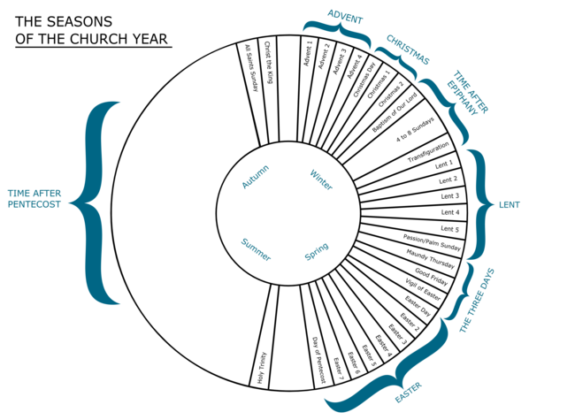
Source: EugeneZ, “The Seasons of the Church Year,” Wikimedia Commons, accessed January 25, 2019, https://commons.wikimedia.org/wiki/File:ChurchYear.png.
Normal text follows the figure source.

CHAPTER THREE

LAW AND GOSPEL
[Text]

CHAPTER FOUR

REFORMATION CONTRIBUTION
[Text]

CHAPTER FIVE

LITURGY AND CONFESSIONS
[Text]

CHAPTER SIX

CONCLUSIONS AND IMPLICATIONS
[Text]

APPENDIX ONE

APPENDIX ONE TITLE
[Text]

APPENDIX TWO

APPENDIX TWO TITLE
[Text]

WORKS CITED
[Bibliography entry]

Sample footnote text.
Use the “Body text after Block Quote” style for this.
Footnote numbers start over in each chapter. Page numbers continue.

