DOCTOR OF MINISTRY
DISSERTATION APPROVAL
The following dissertation entitled
[DISSERTATION TITLE: SUBTITLE]
and written by
[Student’s Full Name]
has been Submitted
to the Concordia Theological Seminary Faculty
in Partial Fulfillment of the Requirements
for the Degree of
DOCTOR OF MINISTRY
This Dissertation stands Approved on this
______ day of _____________________, 20_____
having been Read by the Undersigned Members
of the Dissertation Committee
____________________________________
[Title and Full Name], Dissertation Committee Chair
____________________________________
[Title and Full Name], Reader
____________________________________
[Title and Full Name], Reader

[DISSERTATION TITLE: SUBTITLE]
by
[Student’s Full Name]
[Degree, School, Location, year]
A DISSERTATION

Submitted to the Faculty of
Concordia Theological Seminary
in partial fulfillment of the requirements
for the degree of
DOCTOR OF MINISTRY

Fort Wayne, Indiana
[Month, year]
© [Year] by [Student Name]. All rights reserved. Protected under the Berne Convention.
ABSTRACT
[Student’s Last Name, First Name, M.I.] “[Dissertation Title: Subtitle].” DMin Dissertation, Fort Wayne, Indiana: Concordia Theological Seminary, [20__]. 18 pp.
[Abstract text.]

[Dedication text]
[Epigraph Text]
—[Source]

CONTENTS
ILLUSTRATIONS vii
TABLES viii
PREFACE ix
ACKNOWLEDGEMENTS x
ABBREVIATIONS xi
GLOSSARY xii
INTRODUCTION 1
Sample Level One Subheading 1
MINISTRY CONTEXT 3
APPENDIX ONE 4
GLOSSARY 5
WORKS CITED 6

ILLUSTRATIONS
Figure 1. The Seasons of the Church Year 3

TABLES
Table 1. Population Trends in NE Brazil 2

PREFACE
[Preface text.]

ACKNOWLEDGEMENTS
[Acknowledgement text]

ABBREVIATIONS
[ABBREV Abbreviation text.]

GLOSSARY
[glossary term. Definition or translation.]

CHAPTER ONE

INTRODUCTION
[This Microsoft Word template provides styles for the first five levels of subheadings. These styles are: Subhead 1, Subhead 2, Subhead 3, and Subhead 4. You may format the fifth level subheading as a short title using the character-based style emphasis at the beginning of a paragraph.]

Sample Level One Subheading
[Body text should be 12 point font, double spaced, with a 0.5” first line indent. The top, bottom, and right margins should be set to 1”, but the left margin is set to 1.25” for binding.]

Sample Level Two Subheading
[Lorem ipsum dolor sit amet, consectetur adipiscing elit. Vestibulum ornare, dui ut consequat finibus, dolor massa aliquet diam, sed fermentum nisl orci id elit.]

Sample Level Three Subheading
[Curabitur eu mi diam. Integer tempus laoreet venenatis. Etiam convallis viverra sodales. Donec sit amet justo dictum, pulvinar arcu quis, pharetra nulla.]

Sample level four subheading
[Proin tortor magna, molestie ac placerat sit amet, aliquet mollis dolor.]
Sample level five subheading. [Pellentesque porta vestibulum purus dignissim varius. Praesent facilisis semper fermentum. Cras suscipit laoreet justo, sed faucibus felis euismod eu.]

The following is a sample table. It demonstrates the Table Title and Table Source styles.
Table 1. Population Trends in NE Brazil
 | Average Memb. Per family | Man as Head | Woman as head
BRAZIL | 3.6 | 75.8 | 24.2
Urban North Region | 4.0 | 71.7 | 28.3
Northeast | 3.9 | 74.2 | 25.8
Southeast | 3.5 | 75.7 | 24.3
South | 3.4 | 79.1 | 20.9
Middle-East | 3.5 | 76.5 | 23.5
Source: PNAD, Rio de Janeiro, 1996. In Leonardo Neitzel, “Mission Outreach and Households in the City of Fortaleza, Northeast Brazil” (D.Miss. diss., Concordia Theological Seminary, 2000), 173.
The following is an example of a block quotation. Note that the entire block quote is left indented. If the block quote spans paragraphs, the beginning of the second paragraph is indented:
Class aptent taciti sociosqu ad litora torquent per conubia nostra, per inceptos himenaeos. Suspendisse sit amet rutrum sem. Donec commodo a nunc vitae pretium. Vestibulum faucibus pretium nisl, sed pellentesque arcu eleifend quis. Sed et nisl odio.
Duis risus est, tempor in varius eu, tempus eu nulla. Fusce in aliquet nulla, in scelerisque nunc. In eu finibus urna. Proin neque dolor.
If the block quote does not finish the paragraph, the following line is not indented.
The normal style begins again with the next paragraph.

CHAPTER TWO

MINISTRY CONTEXT
[Notice that a section break is used between chapters. This allows the footnote numbers to start over in each chapter, yet the page numbers continue. It also allows the page number for the first page of the chapter to be placed at the bottom and centered and every subsequent page number to be placed at the top and flushed right.] The following is a sample figure. It demonstrates the Figure Title and Figure Source styles.
Figure 1. The Seasons of the Church Year
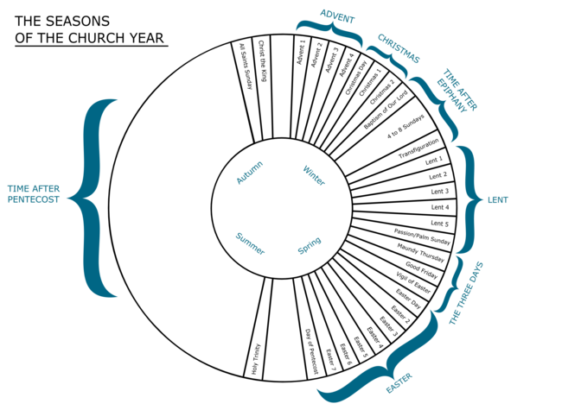
Source: EugeneZ, “The Seasons of the Church Year,” Wikimedia Commons, accessed January 25, 2019, https://commons.wikimedia.org/wiki/File:ChurchYear.png.
Normal text follows the figure source.

APPENDIX ONE
APPENDIX ONE TITLE
[Text]

GLOSSARY
[glossary term. Definition or translation.]

WORKS CITED
[Bibliography entry]

Sample footnote text.
Use the “Body text after Block Quote” style for this.
Footnote numbers start over in each chapter. Page numbers continue.

